TITOUMAX 2013-2014

November

December

January

February 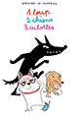
- March

- April

May

June

