KILIMAX 2013-2014

November 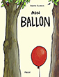

December 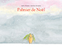

January 

February 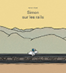

March 

April 

May 

June 

