MINIMAX 2013-2014

November

December

January 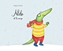

February 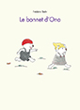

March

April

May 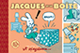

June

